**DAYANANDA SAGAR ACADEMY OF TECHNOLOGY & MANAGEMENT**

22Mile,B.MKaval,Opp. To Art of Living,Uayapura,Kanakapura Road,Bengaluru-82

Affiliated to VTU,Belagavi,Approved by AICTE,NewDelhi

Accredited by NBA,NewDelhi

**DEPARTMENT OF COMPUTER SCIENCE & ENGINEERING**



**Academic Year:2018-2019**

**WEB TECHNOLOGY LABORATORY WITH MINIPROJECT**

**(15CSL77)**

**Compiled By:**

Mrs. Keerthi Mohan

Asst. Professor

Ms. Jahnavi S

Asst. Professor

**CONTENTS**

|  |  |  |  |  |
| --- | --- | --- | --- | --- |
|  |  |  |  | **Page no.** |
| 1. | Syllabus |  |  | 1 |
| 2. | Program 1 - | | JavaScript : Simple calculator | 4 |
| 3. | Program 2 - | | JavaScript : Calculate squares and cubes of the numbers from | 7 |
|  | 0 to 10 |  |  |  |
| 4. | Program 3 | - JavaScript : TEXT-GROWING and TEXT-SHRINKING | | 9 |
| 5. | Program 4 | - HTML5 and JavaScript : | | 11 |

1. position in the string of the left-most vowel
2. number with its digits in the reverse order

|  |  |  |  |  |
| --- | --- | --- | --- | --- |
| 6. | Program 5 | - XML document to store information about a student | | 14 |
| 7. | Program 6 | - | PHP : display the number of visitors visiting the web page. | 17 |
| 8. | Program 7 | - | PHP : display digital clock with current time of the server. | 18 |
| 9. | Program 8 | - PHP : | |  |

|  |  |  |
| --- | --- | --- |
| a) | Implement simple calculator operations. | 19 |
| b) | Find the Transpose of a matrix, Multiplication of two matrices and | 22 |
|  | Addition of two matrices. |  |

|  |  |  |
| --- | --- | --- |
| 10. | Program 9 – PHP : program with variable states with value | 25 |
|  | “Mississippi Alabama Texas Massachusetts Kansas" |  |
| 11. | Program 10 – PHP : program to sort the student records using selection sort. | 27 |

|  |  |
| --- | --- |
| **Web Technology Lab With Mini Project – 15CSL77** | **2018-2019** |
|  |  |

**WEB TECHNOLOGY LABORATORY WITH MINI PROJECT**

[As per Choice Based Credit System (CBCS) scheme] (Effective from the academic year 2016 -2017)

|  |  |  |  |
| --- | --- | --- | --- |
| **Subject Code** | 15CSL77 | **IA Marks** | 20 |
|  |  |  |  |
| **Number of Lecture Hours/Week** | 01I + 02P | **Exam Marks** | 80 |
|  |  |  |  |
| **Total Number of Lecture Hours** | 40 | **Exam Hours** | 03 |
|  |  |  |  |

1. Write a JavaScript to design a simple calculator to perform the following operations: sum, product, difference and quotient.
2. Write a JavaScript that calculates the squares and cubes of the numbers from 0 to 10and outputs HTML text that displays the resulting values in an HTML table format.
3. Write a JavaScript code that displays text “TEXT-GROWING” with increasing font size in the interval of 100ms in RED COLOR, when the font size reaches 50pt it displays “TEXT-SHRINKING” in BLUE color. Then the font size decreases to 5pt.
4. Develop and demonstrate a HTML5 file that includes JavaScript script that uses functions for the following problems:
   1. Parameter: A string
   2. Output: The position in the string of the left-most vowel
   3. Parameter: A number
   4. Output: The number with its digits in the reverse order
5. Design an XML document to store information about a student in an engineering college affiliated to VTU. The information must include USN, Name, and Name of the College, Branch, Year of Joining, and email id. Make up sample data for 3students. Create a CSS style sheet and use it to display the document.
6. Write a PHP program to keep track of the number of visitors visiting the web page and to display this count of visitors, with proper headings.
7. Write a PHP program to display a digital clock which displays the current time of the server.



**Dept. of CSE, DSATM** **Page 1**

|  |  |
| --- | --- |
| **Web Technology Lab With Mini Project – 15CSL77** | **2018-2019** |
|  |  |

1. Write the PHP programs to do the following:
   1. Implement simple calculator operations.
   2. Find the transpose of a matrix.
   3. Multiplication of two matrices.
   4. Addition of two matrices.
2. Write a PHP program named states.py that declares a variable states with value “Mississippi Alabama Texas Massachusetts Kansas". write a PHP program that does the following:
   1. Search for a word in variable states that ends in xas. Store this word in element0 of a list named states List.
   2. Search for a word in states that begins with k and ends in s. Perform a case-insensitive comparison. [Note: Passing re.Ias a second parameter to method compile performs a case-insensitive comparison.] Store this word in element1of states List.
   3. Search for a word in states that begins with M and ends in s. Store this word in element 2 of the list.
   4. Search for a word in states that ends in a. Store this word in element 3 of the list.
3. Write a PHP program to sort the student records which are stored in the database using selection sort.



**Dept. of CSE, DSATM** **Page 2**

|  |  |
| --- | --- |
| **Web Technology Lab With Mini Project – 15CSL77** | **2018-2019** |
|  |  |

**Study Experiment / Project:**

Develop a web application project using the languages and concepts learnt in the theory and Exercises listed in part A with a good look and feel effects. You can use any web technologies and frameworks and databases.

**Note:**

1. In the examination each student picks one question from part A.
2. A team of two or three students must develop the mini project. However duringthe examination, each student must demonstrate the project individually.
3. The team must submit a brief project report (15-20 pages) that must include thefollowing:
   1. Introduction
   2. Requirement Analysis
   3. Software Requirement Specification
   4. Analysis and Design
   5. Implementation
   6. Testing

**Course outcomes:** The students should be able to:

* Design and develop dynamic web pages with good aesthetic sense of designingand latest technical know-how's.
* Have a good understanding of Web Application Terminologies, Internet Toolsother web services.
* Learn how to link and publish web sites

**Conduction of Practical Examination:**

* 1. All laboratory experiments from part A are to be included for practicalexamination.
  2. Mini project has to be evaluated for 30 Marks.
  3. Report should be prepared in a standard format prescribed for project work.
  4. Students are allowed to pick one experiment from the lot.
  5. Strictly follow the instructions as printed on the cover page of answer script.
  6. Marks distribution:

1. Part A: Procedure + Conduction + Viva:10 + 35 +5 =50 Marks
2. Part B: Demonstration + Report + Viva voce = 15+10+05 = 30 Marks. Change of experiment is allowed only once and marks allotted to the procedure part to be made zero.



**Dept. of CSE, DSATM** **Page 3**

|  |  |
| --- | --- |
| **Web Technology Lab With Mini Project – 15CSL77** | **2018-2019** |
|  |  |

1. **Write a JavaScript to design a simple calculator to perform the following operations: sum, product, difference and quotient.**

**program1.html** <!DOCTYPE HTML> <html>

<head>

<style>

table, td, th

{

border: 1px solid black;

width: 33%;

text-align: center;

background-color: DarkGray;

border-collapse:collapse;

}

table { margin: auto; }

input { text-align:right; }

</style>

<script type="text/javascript">

function calc(clicked_id)

{

var val1 = parseFloat(document.getElementById("value1").value); var val2 = parseFloat(document.getElementById("value2").value); if(isNaN(val1)||isNaN(val2))

alert("ENTER VALID NUMBER");

else if(clicked_id=="add")

document.getElementById("answer").value=val1+val2; else if(clicked_id=="sub")

document.getElementById("answer").value=val1-val2; else if(clicked_id=="mul")

document.getElementById("answer").value=val1*val2;



**Dept. of CSE, DSATM** **Page 4**

|  |  |
| --- | --- |
| **Web Technology Lab With Mini Project – 15CSL77** | **2018-2019** |
|  |  |

else if(clicked_id=="div")

document.getElementById("answer").value=val1/val2;

}

function cls()

{

value1.value="0";

value2.value="0";

answer.value="";

}

</script>

</head>

<body>

<table>

<tr><th colspan="4"> SIMPLE CALCULATOR </th></tr> <tr><td>value1</td><td><input type="text" id="value1" value="0"/></td> <td>value2</td><td><input type="text" id="value2" value="0"/> </td></tr> <tr><td><input type="button" value="Addition" id = "add" onclick="calc(this.id)"/></td>

<td><input type="button" value="Subtraction" id = "sub"

onclick="calc(this.id)"/></td>

<td><input type="button" value="Multiplication" id = "mul"

onclick="calc(this.id)"/></td>

<td><input type="button" value="Division" id ="div"

onclick="calc(this.id)"/></td></tr>

<tr><td>Answer:</td><td> <input type="text" id="answer" value=""

disabled/></td>

<td colspan="2"><input type="button" value="CLEAR ALL" onclick="cls()"/></td> </tr>

</table>

</body>

</html>



**Dept. of CSE, DSATM** **Page 5**

|  |  |  |  |
| --- | --- | --- | --- |
|  | **Web Technology Lab With Mini Project – 15CSL77** | | **2018-2019** |
|  |  |  |  |
|  | **Output:** | |  |
|  |  |  |  |

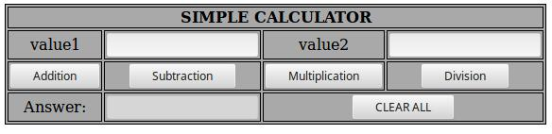

**Test Cases :**

|  |  |  |  |  |
| --- | --- | --- | --- | --- |
| **Test** | **Input** | **Expected Output** | **Obtained Output** | **Remarks** |
| **No.** | **Parameters** |
|  |  |  |
|  |  |  |  |  |
|  |  | Addition =74.95 | Addition =74.95 |  |
| 1. | value1=50.56 | Subtraction =26.17 | Subtraction =26.17 | PASS |
| value2=24.39 | Multiplication=1233.1584 | Multiplication=1233.1584 |
|  |  |
|  |  | Division=2.072980729807298 | Division=2.072980729807298 |  |
|  |  |  |  |  |
|  |  | Addition =45 | Addition =45 |  |
| 2. | value1= 0 | Subtraction =-45 | Subtraction =-45 | PASS |
| value2= 45 | Multiplication=0 | Multiplication=0 |
|  |  |
|  |  | Division=0 | Division=0 |  |
|  |  |  |  |  |
|  |  | Addition =45 | Addition =45 |  |
| 3. | value1= 45 | Subtraction =45 | Subtraction =45 | PASS |
| value2= 0 | Multiplication=0 | Multiplication=0 |
|  |  |
|  |  | Division=Infinity | Division=Infinity |  |
|  |  |  |  |  |
| 4. | value1 = abc | ENTER VALID NUMBER | ENTER VALID NUMBER | PASS |
| value2 = 23 |
|  |  |  |  |
|  |  |  |  |  |
| 5 | value1 = 50 | ENTER VALID NUMBER | ENTER VALID NUMBER | PASS |
| value2 =xyz |
|  |  |  |  |
|  |  |  |  |  |



**Dept. of CSE, DSATM** **Page 6**

|  |  |
| --- | --- |
| **Web Technology Lab With Mini Project – 15CSL77** | **2018-2019** |
|  |  |

1. **Write a JavaScript that calculates the squares and cubes of the numbers from 0 to 10 and outputs HTML text that displays the resulting values in an HTML table format.**

**program2.html** <!DOCTYPE HTML> <html>

<head>

<style> table,tr, td

{

border: solid black;

width: 33%;

text-align: center;

border-collapse: collapse; background-color:lightblue;

}

table { margin: auto; }

</style>

<script>

document.write( "<table><tr><th colspan='3'> NUMBERS FROM 0 TO 10 WITH THEIR SQUARES AND CUBES </th></tr>" );

document.write( "<tr><td>Number</td><td>Square</td><td>Cube</td></tr>" );

for(var n=0; n<=10; n++)

{

document.write( "<tr><td>" + n + "</td><td>" + n*n + "</td><td>" + n*n*n + "</td></tr>" ) ;

}

document.write( "</table>" ) ;

</script>

</head>

</html>



**Dept. of CSE, DSATM** **Page 7**

|  |  |
| --- | --- |
| **Web Technology Lab With Mini Project – 15CSL77** | **2018-2019** |
|  |  |

**Output:**

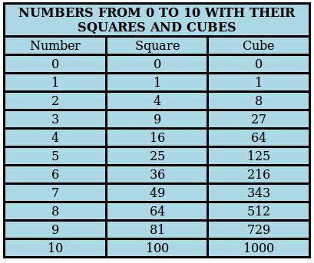

**Dept. of CSE, DSATM** **Page 8**

|  |  |
| --- | --- |
| **Web Technology Lab With Mini Project – 15CSL77** | **2018-2019** |
|  |  |

1. **Write a JavaScript code that displays text “TEXT-GROWING” with increasing font size in the interval of 100ms in RED COLOR, when the font size reaches**

**50pt it displays “TEXT-SHRINKING” in BLUE color. Then the font size decreases to 5pt.**

**program3.html**

<!DOCTYPE HTML>

<html>

<head>

<style>

p {

position: absolute;

top: 50%;

left: 50%;

transform: translate(-50%, -50%);

}

</style>

</head>

<body>

<p id="demo"></p>

<script>

var var1 = setInterval(inTimer, 1000);

var fs = 5;

var ids = document.getElementById("demo");

function inTimer() {

ids.innerHTML = 'TEXT GROWING'; ids.setAttribute('style', "font-size: " + fs + "px; color: red"); fs += 5;

if(fs >= 50 ){

clearInterval(var1);

var2 = setInterval(deTimer, 1000);

}

}



**Dept. of CSE, DSATM** **Page 9**

|  |  |
| --- | --- |
| **Web Technology Lab With Mini Project – 15CSL77** | **2018-2019** |
|  |  |

function deTimer() {

fs -= 5;

ids.innerHTML = 'TEXT SHRINKING'; ids.setAttribute('style', "font-size: " + fs + "px; color:blue"); if(fs === 5 ){

clearInterval(var2);

}

}

</script>

</body>

</html>

**Output:**



**TEXT SHRINKING**



**Dept. of CSE, DSATM** **Page 10**

|  |  |
| --- | --- |
| **Web Technology Lab With Mini Project – 15CSL77** | **2018-2019** |
|  |  |

1. **Develop and demonstrate a HTML5 file that includes JavaScript script that uses functions for the following problems:**
   1. **Parameter: A string**
   2. **Output: The position in the string of the left-most vowel**
   3. **Parameter: A number**
   4. **Output: The number with its digits in the reverse order**

**program4.html**

<!DOCTYPE HTML>

<html>

<body>

<script type="text/javascript">

var str = prompt("Enter the Input","");

if(!(isNaN(str)))

{

var num,rev=0,remainder;

num = parseInt(str);

while(num!=0) {

remainder = num%10;

num = parseInt(num/10);

rev = rev * 10 + remainder;

}

alert("Reverse of "+str+" is "+rev);

}

else

{

str = str.toUpperCase();

for(var i = 0; i < str.length; i++) {

var chr = str.charAt(i);

if(chr == 'A' || chr == 'E' || chr == 'I' || chr == 'O' || chr == 'U')break;

}



**Dept. of CSE, DSATM** **Page 11**

|  |  |
| --- | --- |
| **Web Technology Lab With Mini Project – 15CSL77** | **2018-2019** |
|  |  |

if( i < str.length )

alert("The position of the left most vowel is "+(i+1));

else

alert("No vowel found in the entered string");

}

</script>

</body>

</html>

**Output** :

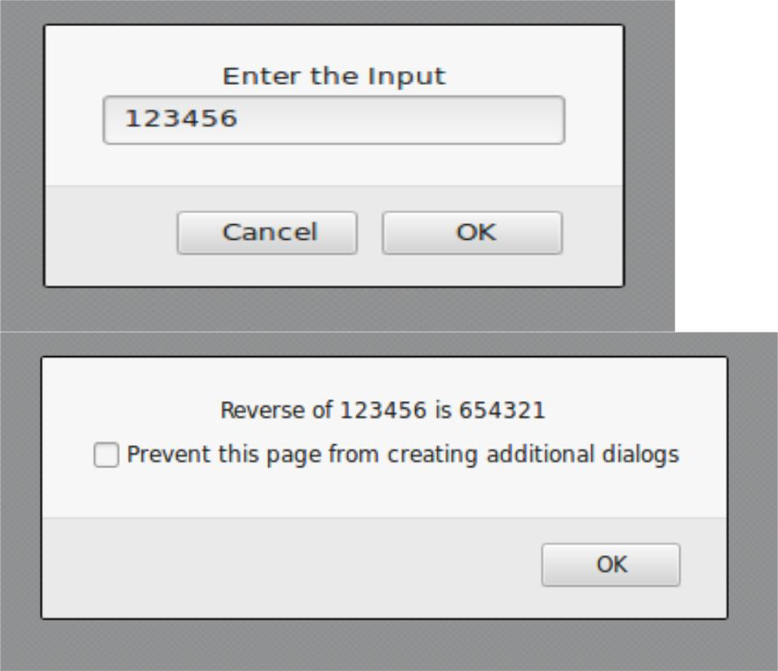

**Dept. of CSE, DSATM** **Page 12**

|  |  |
| --- | --- |
| **Web Technology Lab With Mini Project – 15CSL77** | **2018-2019** |
|  |  |

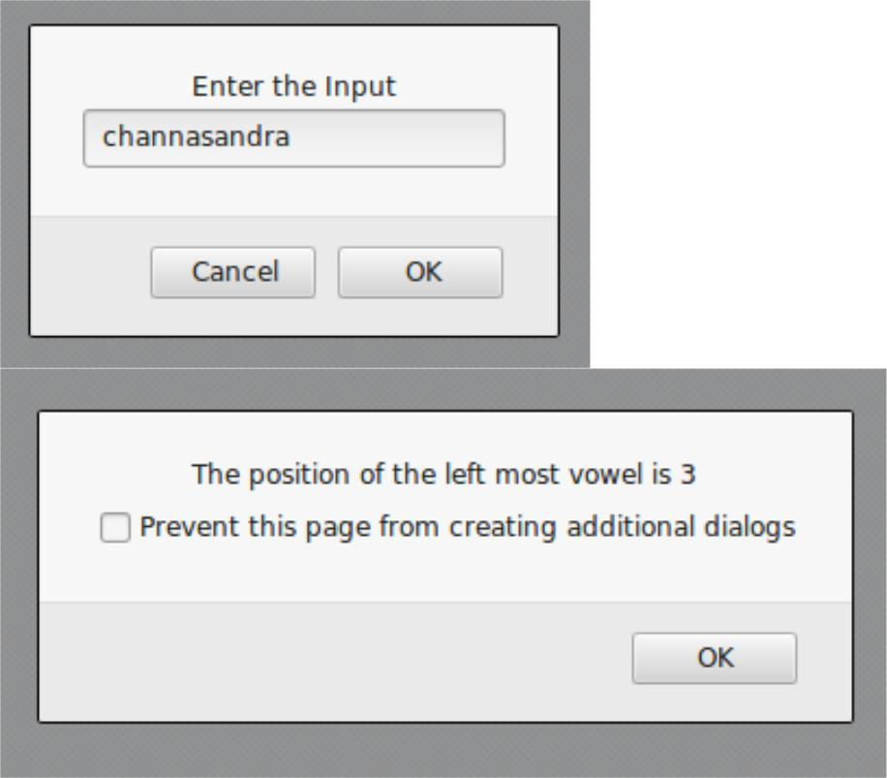

**Test Cases :**

|  |  |  |  |  |
| --- | --- | --- | --- | --- |
| **Test** | **Input Parameters** | **Expected Output** | **Obtained Output** | **Remarks** |
| **No.** |
|  |  |  |  |
|  |  |  |  |  |
| 1. | 123 | Reverse of 123 is 321 | Reverse of 123 is 321 | PASS |
|  |  |  |  |  |
| 1. | CHANNASANDRA | The position of the left | The position of the left | PASS |
| most vowel is 3 | most vowel is 3 |
|  |  |  |
| 2. | SKY | No vowel found in the | No vowel found in the | PASS |
| entered string | entered string |
|  |  |  |
| 3. | MNKTO | The position of the left | The position of the left | PASS |
| most vowel is 5 | most vowel is 5 |
|  |  |  |
|  |  |  |  |  |



**Dept. of CSE, DSATM** **Page 13**

|  |  |
| --- | --- |
| **Web Technology Lab With Mini Project – 15CSL77** | **2018-2019** |
|  |  |

1. **Design an XML document to store information about a student in an engineering college affiliated to VTU. The information must include USN, Name, and Name of the College, Branch, Year of Joining, and email id. Make up sample data for 3 students. Create a CSS style sheet and use it to display the document.**

**program5.xml**

<?xml-stylesheet type="text/css" href="pgm5.css" ?>

<!DOCTYPE HTML>

<html>

<head>

<h1> STUDENTS DESCRIPTION </h1>

|  |  |  |
| --- | --- | --- |
| </head> |  |  |
| <students> |  |  |
| <student> |  |  |
| <USN>USN | : 1DT14CS001</USN> | |
| <name>NAME | : AAKASH</name> | |
| <college>COLLEGE : DSATM</college> | | |
| <branch>BRANCH | : | Computer Science and Engineering</branch> |
| <year>YEAR | : | 2014</year> |
| <e-mail>E-Mail | : | aakash@gmail.com</e-mail> |
| </student> |  |  |
| <student> |  |  |
| <USN>USN | : 1DT14CS012</USN> | |
| <name>NAME | : MADHU</name> | |
| <college>COLLEGE : DSATM</college> | | |
| <branch>BRANCH | : Computer Science and Engineering</branch> | |
| <year>YEAR | : | 2014</year> |
| <e-mail>E-Mail | : | madhu@gmail.com</e-mail> |
| </student> |  |  |
| <student> |  |  |
| <USN>USN | : 1DT15EC401</USN> | |
| <name>NAME | : RAM</name> | |
| <college>COLLEGE : | | DSATM</college> |
|  |  |  |
|  |  |  |
| **Dept. of CSE, DSATM** |  | **Page 14** |

|  |  |  |  |
| --- | --- | --- | --- |
| **Web Technology Lab With Mini Project – 15CSL77** | | | **2018-2019** |
|  |  | | |
| <branch>BRANCH | : Electronics and Communication Engineering | | |
| </branch> |  |  |  |
| <year>YEAR | : | 2015</year> |  |
| <e-mail>E-Mail | : | ram@gmail.com</e-mail> |  |
| </student> |  |  |  |
| </students> |  |  |  |
| </html> |  |  |  |

**pgm5.css**

student{

display:block; margin-top:10px; color:Navy;

}

USN{

display:block; margin-left:10px;font-size:14pt; color:Red;

}

name{

display:block; margin-left:20px;font-size:14pt; color:Blue;

}

college{

display:block; margin-left:20px;font-size:12pt; color:Maroon;

}

branch{

display:block; margin-left:20px;font-size:12pt; color:Purple;

}

year{

display:block; margin-left:20px;font-size:14pt; color:Green;

}

e-mail{

display:block; margin-left:20px;font-size:12pt; color:Blue;

}



**Dept. of CSE, DSATM** **Page 15**

|  |  |
| --- | --- |
| **Web Technology Lab With Mini Project – 15CSL77** | **2018-2019** |
|  |  |

**Output:**

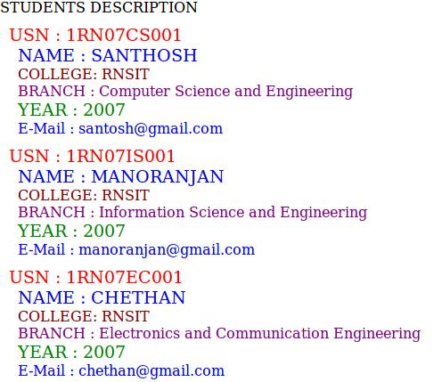

**Dept. of CSE, DSATM** **Page 16**

|  |  |
| --- | --- |
| **Web Technology Lab With Mini Project – 15CSL77** | **2018-2019** |
|  |  |

1. **Write a PHP program to keep track of the number of visitors visiting the web**

**page and to display this count of visitors, with proper headings.**

**program6.php**

<?php

print "<h3> REFRESH PAGE </h3>";

$name="counter.txt";

$file = fopen($name,"r");

$hits= fscanf($file,"%d");

fclose($file);

$hits[0]++;

$file = fopen($name,"w");

fprintf($file,"%d",$hits[0]);

fclose($file);

print "Total number of views: ".$hits[0];

?>

**Output:**

**REFRESH PAGE**

**Total number of views: 10**



**Dept. of CSE, DSATM** **Page 17**

|  |  |
| --- | --- |
| **Web Technology Lab With Mini Project – 15CSL77** | **2018-2019** |
|  |  |

1. **Write a PHP program to display a digital clock which displays the current time**

**of the server.**

**program7.php**

<!DOCTYPE HTML>

<html>

<head>

<meta http-equiv="refresh" content="1"/>

<style>

p {

color:white;

font-size:90px;

position: absolute;

top: 50%;

left: 50%;

transform: translate(-50%, -50%);

}

body{background-color:black;}

</style>

<p> <?php echo date(" h: i : s A");?> </p>

</head>

**Output:**



**Dept. of CSE, DSATM** **Page 18**

|  |  |
| --- | --- |
| **Web Technology Lab With Mini Project – 15CSL77** | **2018-2019** |
|  |  |

1. **Write the PHP programs to do the following:**
   1. **Implement simple calculator operations.**
   2. **Find the transpose of a matrix.**
   3. **Multiplication of two matrices.**
   4. **Addition of two matrices.**

**program8a.php**

<html>

<head>

<style>

table, td, th

{

border: 1px solid black;

width: 35%;

text-align: center;

background-color: DarkGray;

}

table { margin: auto; }

input,p { text-align:right; }

</style>

</head>

<body>

<form method="post">

<table>

<caption><h2> SIMPLE CALCULATOR </h2></caption>> <tr><td>First Number:</td><td><input type="text" name="num1" /></td>

<td rowspan="2"><input type="submit" name="submit"

value="calculate"></td></tr>

<tr><td>Second Number:</td><td><input type="text"

name="num2"/></td></tr>

</form>

<?php

if(isset($_POST['submit'])) // it checks if the input submit is filled



**Dept. of CSE, DSATM** **Page 19**

|  |  |
| --- | --- |
| **Web Technology Lab With Mini Project – 15CSL77** | **2018-2019** |
|  |  |

{

$num1 = $_POST['num1'];

$num2 = $_POST['num2'];

if(is_numeric($num1) andis_numeric($num1) )

{

echo "<tr><td> Addition :</td><td><p>".($num1+$num2)."</p></td>";

echo "<tr><td> Subtraction :</td><td><p> ".($num1-$num2)."</p></td>";

echo "<tr><td> Multiplication :</td><td><p>".($num1*$num2)."</p></td>";

echo "<tr><td>Division :</td><td><p> ".($num1/$num2)."</p></td>";

echo "</table>";

}

else

{

echo"<script type='text/javascript' > alert(' ENTER VALID NUMBER');</script>";

}

}

?>

</body>

</html>



**Dept. of CSE, DSATM** **Page 20**

|  |  |
| --- | --- |
| **Web Technology Lab With Mini Project – 15CSL77** | **2018-2019** |
|  |  |
| **Output:** |  |

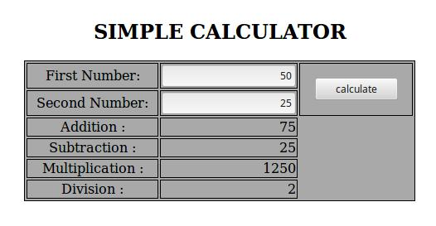

**Test Cases:**

|  |  |  |  |  |  |  |
| --- | --- | --- | --- | --- | --- | --- |
|  | **Test** | **Input** | **Expected Output** | **Obtained Output** | **Remarks** | |
|  | **No.** | **Parameters** |
|  |  |  |  |  |
|  |  |  |  |  |  |  |
|  |  |  | Addition =74.95 | Addition =74.95 |  |  |
|  | 1. | value1=50.56 | Subtraction =26.17 | Subtraction =26.17 | PASS | |
|  | value2=24.39 | Multiplication=1233.1584 | Multiplication=1233.1584 |
|  |  |  |  |
|  |  |  | Division=2.072980729807298 | Division=2.072980729807298 |  |  |
|  |  |  |  |  |  |  |
|  |  |  | Addition =45 | Addition =45 |  |  |
|  | 2. | value1= 0 | Subtraction =-45 | Subtraction =-45 | PASS | |
|  | value2= 45 | Multiplication=0 | Multiplication=0 |
|  |  |  |  |
|  |  |  | Division=0 | Division=0 |  |  |
|  |  |  |  |  |  |  |
|  |  |  | Addition =45 | Addition =45 |  |  |
|  | 3. | value1= 45 | Subtraction =45 | Subtraction =45 | PASS | |
|  | value2= 0 | Multiplication=0 | Multiplication=0 |
|  |  |  |  |
|  |  |  | Division=Infinity | Division=Infinity |  |  |
|  |  |  |  |  |  |  |
|  | 4. | value1 = abc | ENTER VALID NUMBER | ENTER VALID NUMBER | PASS | |
|  | value2 = 23 |
|  |  |  |  |  |  |
|  |  |  |  |  |  |  |
|  | 5 | value1 = 50 | ENTER VALID NUMBER | ENTER VALID NUMBER | PASS | |
|  | value2 =xyz |
|  |  |  |  |  |  |
|  |  |  |  |  |  | |
|  |  |  |  |  |  |  |
|  |  |  |  |  |  |  |
|  | **Dept. of CSE, DSATM** | | |  | **Page 21** | |

|  |  |
| --- | --- |
| **Web Technology Lab With Mini Project – 15CSL77** | **2018-2019** |
|  |  |

**Program8b.php**

<?php

$a = array(array(1,2,3),array(4,5,6),array(7,8,9));

$b = array(array(7,8,9),array(4,5,6),array(1,2,3));

$m=count($a);

$n=count($a[2]);

$p=count($b);

$q=count($b[2]);

echo "the first matrix :"."<br/>";

for ($row = 0; $row < $m; $row++) {

for ($col = 0; $col < $n; $col++)

echo " ".$a[$row][$col];

echo "<br/>";

}

echo "the second matrix :"."<br/>";

for ($row = 0; $row < $p; $row++) {

for ($col = 0; $col < $q; $col++)

echo " ".$b[$row][$col];

echo "<br/>";

}

echo "the transpose for the first matrix is:"."<br/>"; for ($row = 0; $row < $m; $row++) {

for ($col = 0; $col < $n; $col++)

echo " ".$a[$col][$row];

echo "<br/>";

}



**Dept. of CSE, DSATM** **Page 22**

|  |  |
| --- | --- |
| **Web Technology Lab With Mini Project – 15CSL77** | **2018-2019** |
|  |  |

if(($m===$p) and ($n===$q)) {

echo "the addition of matrices is:"."<br/>";

for ($row = 0; $row < 3; $row++) {

for ($col = 0; $col < 3; $col++)

echo " ".$a[$row][$col]+$b[$row][$col]." "; echo "<br/>";

}

}

if($n===$p){

echo " The multiplication of matrices: <br/>";

$result=array();

for ($i=0; $i < $m; $i++) {

for($j=0; $j < $q; $j++){

$result[$i][$j] = 0;

for($k=0; $k < $n; $k++)

$result[$i][$j] += $a[$i][$k] * $b[$k][$j];

}

}

for ($row = 0; $row < $m; $row++) {

for ($col = 0; $col < $q; $col++)

echo " ".$result[$row][$col];

echo "<br/>";

}

}

?>



**Dept. of CSE, DSATM** **Page 23**

|  |  |
| --- | --- |
| **Web Technology Lab With Mini Project – 15CSL77** | **2018-2019** |
|  |  |

**Output:**

**the first matrix:**

**1 2 3**

**4 5 6**

**7 8 9**

**the second matrix:**

**7 8 9**

**4 5 6**

**1 2 3**

**the transpose of the first matrix:**

**1 4 7**

**2 5 8**

**3 6 9**

**the addition of matrices is:**

**8 10 12**

**8 10 12**

**8 10 12**

**the multiplication of matrices:**

**18 24 30**

**54 69 84**

**90 114 138**



**Dept. of CSE, DSATM** **Page 24**

|  |  |
| --- | --- |
| **Web Technology Lab With Mini Project – 15CSL77** | **2018-2019** |
|  |  |

1. **Write a PHP program named states.py that declares a variable states with value "Mississippi Alabama Texas Massachusetts Kansas". write a PHP program that does the following:**
   1. **Search for a word in variable states that ends in xas. Store this word in element 0 of a list named statesList.**
   2. **Search for a word in states that begins with k and ends in s. Perform a case-insensitive comparison. [Note: Passing re.Ias a second parameter to method compile performs a case-insensitive comparison.] Store this word in element1 of statesList.**
   3. **Search for a word in states that begins with M and ends in s. Store this word in element 2 of the list.**
   4. **Search for a word in states that ends in a. Store this word in element 3 of the list.**

**program9.php**

<?php

$states = "Mississippi Alabama Texas Massachusetts Kansas"; $statesArray = [];

$states1 = explode(' ',$states);

echo "Original Array :<br>";

foreach ( $states1 as $i => $value )

print("STATES[$i]=$value<br>");

foreach($states1 as $state) {

if(preg_match( '/xas$/', ($state)))

$statesArray[0] = ($state);

}

foreach($states1 as $state) {

if(preg_match('/^k.*s$/i', ($state)))

$statesArray[1] = ($state);

}



**Dept. of CSE, DSATM** **Page 25**

|  |  |
| --- | --- |
| **Web Technology Lab With Mini Project – 15CSL77** | **2018-2019** |
|  |  |

foreach($states1 as $state) {

if(preg_match('/^M.*s$/', ($state)))

$statesArray[2] = ($state);

}

foreach($states1 as $state){

if(preg_match('/a$/', ($state)))

$statesArray[3] = ($state);

}

echo "<br><br>Resultant Array :<br>";

foreach ( $statesArray as $array => $value )

print("STATES[$array]=$value<br>");

?>

**Output:**

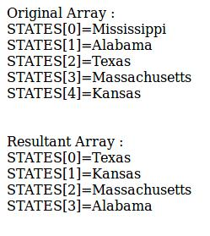

**Dept. of CSE, DSATM** **Page 26**

|  |  |
| --- | --- |
| **Web Technology Lab With Mini Project – 15CSL77** | **2018-2019** |
|  |  |

1. **Write a PHP program to sort the student records which are stored in the database using selection sort.**

**Goto Mysql and then type**

create database weblab;

use weblab;

create table student(usnvarchar(10),name varchar(20),address varchar(20));

**program10.php**

<!DOCTYPE html>

<html>

<body>

<style>

table, td, th

{

border: 1px solid black;

width: 33%;

text-align: center;

border-collapse:collapse;

background-color:lightblue;

}

table { margin: auto; }

</style>

<?php

$servername = "localhost";

$username = "root";

$password = "root";

$dbname = "weblab";

$a=[];

**// Create connection**

**// Opens a new connection to the MySQL server**

$conn = mysqli_connect($servername, $username, $password, $dbname);



**Dept. of CSE, DSATM** **Page 27**

|  |  |
| --- | --- |
| **Web Technology Lab With Mini Project – 15CSL77** | **2018-2019** |
|  |  |

* **Check connection and return an error description from the last connection error, if any**

if ($conn->connect_error)

die("Connection failed: " . $conn->connect_error);

$sql = "SELECT * FROM student";

* **performs a query against the database**

$result = $conn->query($sql);

echo "<br>";

echo "<center> BEFORE SORTING </center>"; echo "<table border='2'>";

echo "<tr>";t

echo "<th>USN</th><th>NAME</th><th>Address</th></tr>"; if ($result->num_rows> 0)

{

* **output data of each row and fetches a result row as an associative array**

while($row = $result->fetch_assoc()){

echo "<tr>";

echo "<td>". $row["usn"]."</td>";

echo "<td>". $row["name"]."</td>";

echo "<td>". $row["addr"]."</td></tr>";

array_push($a,$row["usn"]);

}

}

else

echo "Table is Empty";

echo "</table>";

$n=count($a);

$b=$a;

for ( $i = 0 ; $i< ($n - 1) ; $i++ )

{

$pos= $i;



**Dept. of CSE, DSATM** **Page 28**

|  |  |
| --- | --- |
| **Web Technology Lab With Mini Project – 15CSL77** | **2018-2019** |
|  |  |

for ( $j = $i + 1 ; $j < $n ; $j++ ) {

if ( $a[$pos] > $a[$j] )

$pos= $j;

}

if ( $pos!= $i ) {

$temp=$a[$i];

$a[$i] = $a[$pos];

$a[$pos] = $temp;

}

}

$c=[];

$d=[];

$result = $conn->query($sql);

if ($result->num_rows> 0)**// output data of each row**

{

while($row = $result->fetch_assoc()) {

for($i=0;$i<$n;$i++) {

if($row["usn"]== $a[$i]) {

$c[$i]=$row["name"];

$d[$i]=$row["addr"];

}

}

}

}

echo "<br>";

echo "<center> AFTER SORTING <center>";

echo "<table border='2'>";

echo "<tr>";

echo "<th>USN</th><th>NAME</th><th>Address</th></tr>"; for($i=0;$i<$n;$i++) {

echo "<tr>";

echo "<td>". $a[$i]."</td>";

echo "<td>". $c[$i]."</td>";



**Dept. of CSE, DSATM** **Page 29**

|  |  |
| --- | --- |
| **Web Technology Lab With Mini Project – 15CSL77** | **2018-2019** |
|  |  |

echo "<td>". $d[$i]."</td></tr>";

}

echo "</table>";

$conn->close();

?>

</body>

</html>

**Output:**

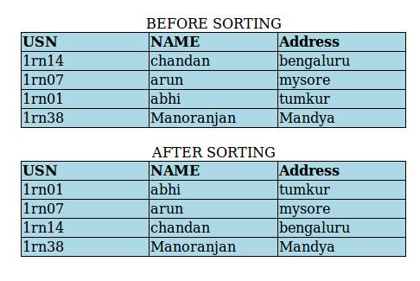

**Dept. of CSE, DSATM** **Page 30**